Dear Families,

I wanted to update you on Zippy books and check in with everyone on how it is going. Each child should be bringing home a plastic Book Bag from school. In the bag will be 1-2 books for you and your child to practice reading after school. I want to emphasize that I do not expect Gr. 2s to be bringing back their Zippy book each day. In order for them to become fluent with their books and more importantly to understand them they need those extra few days of daily practice with that particular book. So please take the time to really become familiar with the book you are reading and ask them good questions about the text. If you only get through a couple pages a night that is ok! Quality is much more beneficial than quantity.

You may have noticed that your child’s level has gone down from where they were reading before. Please don’t be alarmed! Many of our Grade 2s can read at higher levels but I am finding they do not understand the main ideas and details in their books. As a result I have put them down a few levels so we can build comprehension and understanding in order to better prepare them for Gr. 3. If you have questions about this please come and talk to me.

Finally I want to introduce a new part of the Zippy book program for Gr.2s. I want to keep it very simple but I think it will be a great tool for our students.

Home Reading Journal – I have sent home a blank green journal to be used with your Zippy books. Students can use this journal to:
- Write down words they are unfamiliar with
- Write down a question they have about the book
- Do a summary on a chapter they just read when reading a chapter book
- Write about if they liked or disliked the book and why

We will use some of our computer time at school to research the questions they have as well as define the unknown words. My hope is that this will engage them even more in their reading and expand their comprehension.

The Zippy Book Bag with the Books, Reading Log and Home Reading Journal will travel back and forth to school. I encourage you to take as much time as needed for your child to become comfortable reading and understanding these books. When you have finished a book bring it back to school to switch it for a new one.

If you have any questions about the new home reading journal please let me know. If not I will be checking in with you in the next couple weeks to see how things are going!

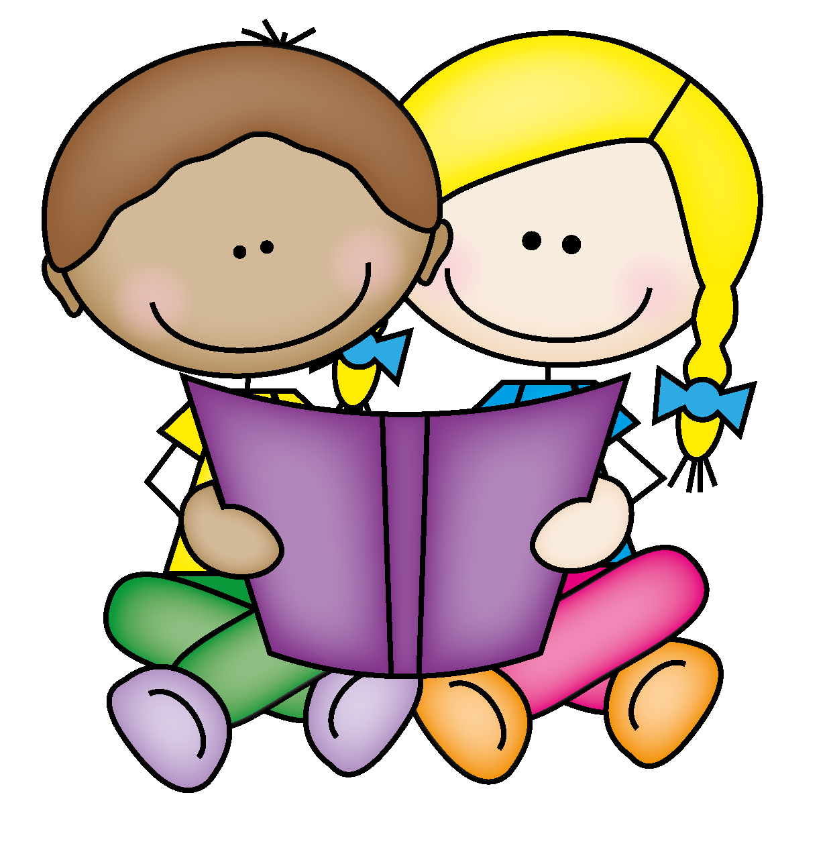
Happy Reading!
Miss. Appleton

